**Module: R5: RV-fpga**

**Section:** Installations **Task:** Tools

**Task 1.5**

**RVfpga-Whisper**

* **Testing:**
  + **RVfpga-Whisper**
    1. Open the specified folder of example program in VS Code:

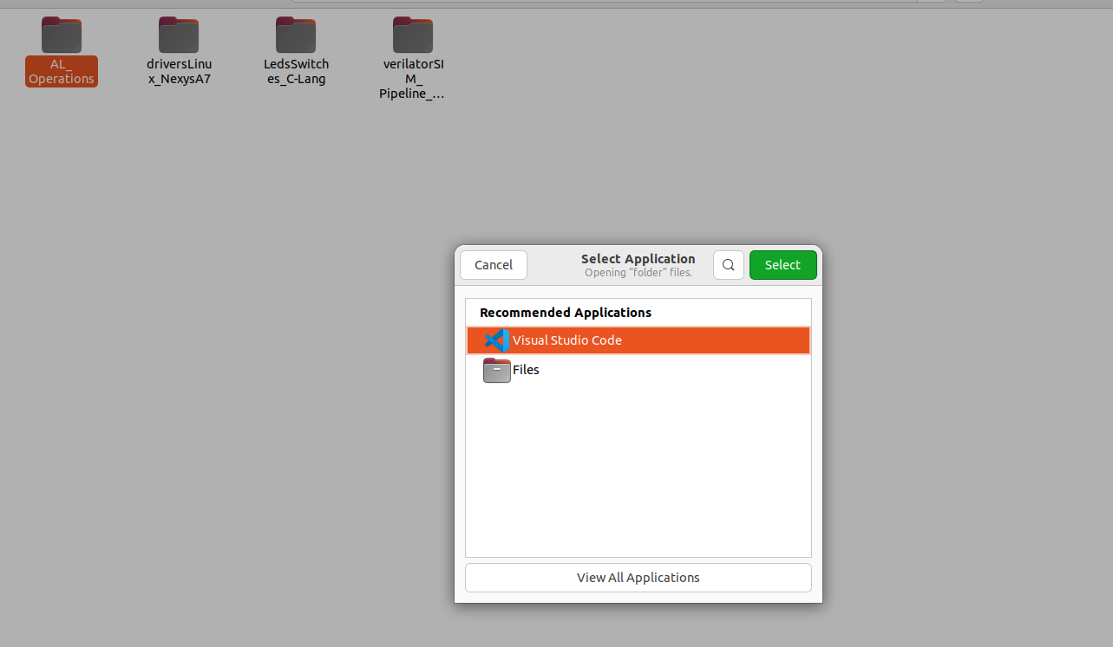

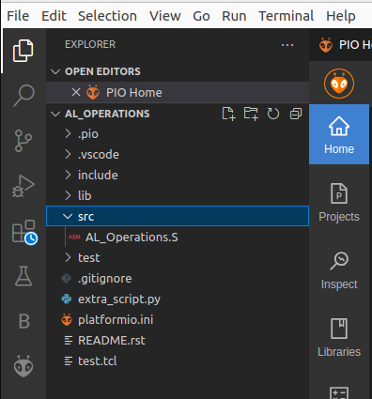

* + 1. PlatformIO will now open this program, which includes three assembly arithmetic-logic instructions (addition, subtraction, and logical and) on the same register, t3 (also called x28), within an infinite loop. We can view the program by expanding the src folder and double-clicking on **AL_Operations.S**.

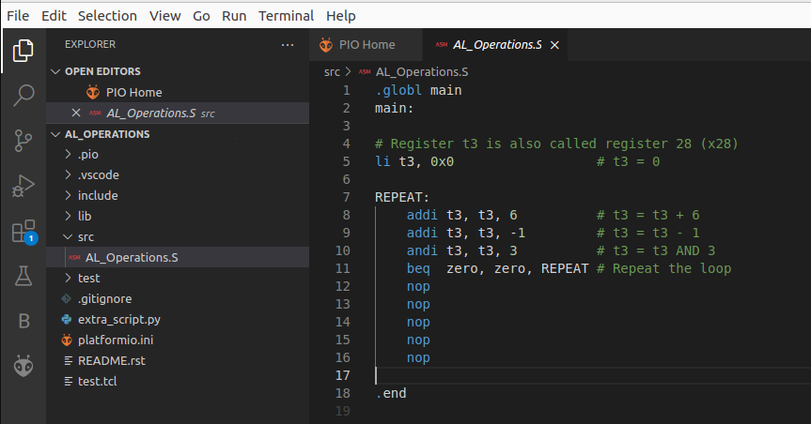

* + 1. Open file **platformio.ini**. Set Whisper as the simulation tool to use the debug tool by uncommenting line 17. Save the file.

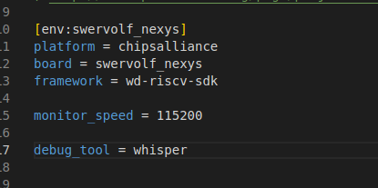

* + 1. Click on the RUN AND DEBUG button in the bar on the left-hand side.
       - Start the debugger by clicking on the Play button PIO Debug (make sure that the "PIO Debug" option is selected).

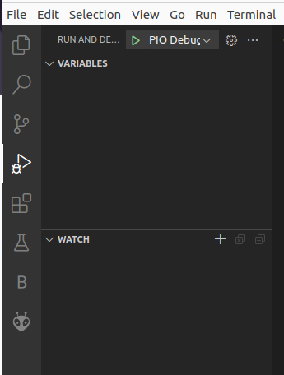

The program will first compile and then debugging will start. To control your debugging session, you can use the debugging toolbar which appears near the top of the editor.

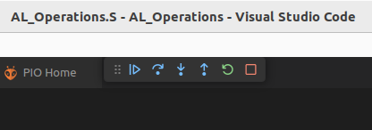

* + 1. PlatformIO will set a temporary breakpoint at the beginning of the main function and we can continue execution step by step and analyze the three arithmetic-logic instructions.

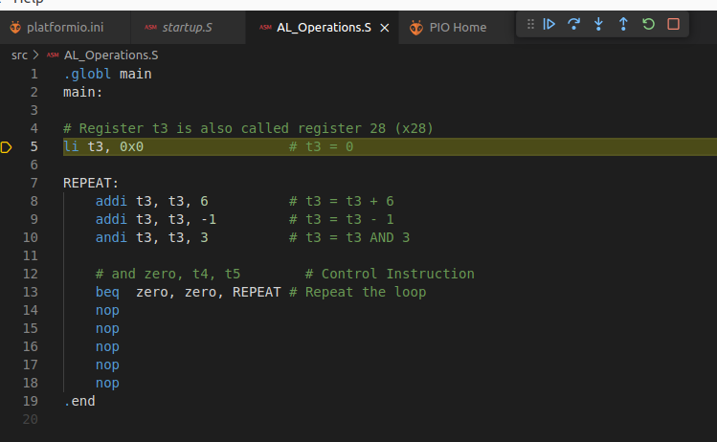

* + 1. Let's step over. This is the first arithmetic-logic instruction, which adds t3, which is initially zero, plus 6.

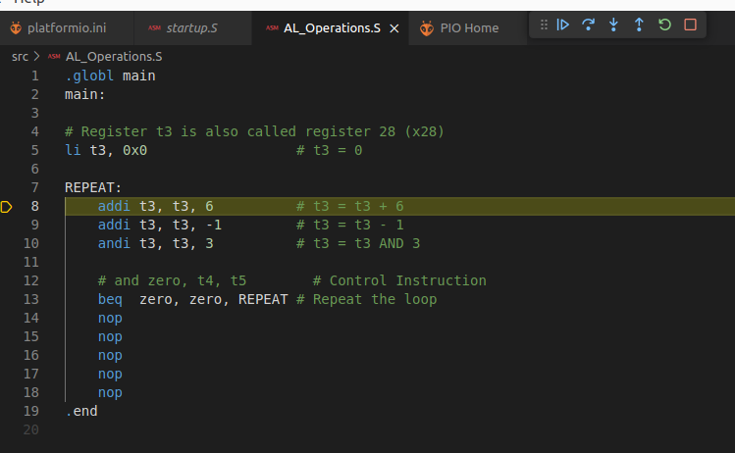

* + 1. Let's open the Registers view, so that we can analyze the values of the t3 register.

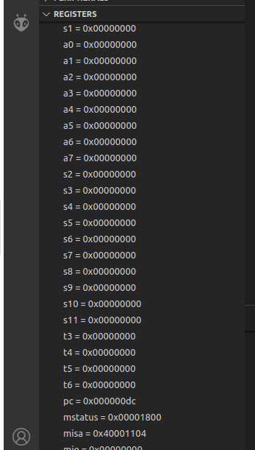

* + 1. When we step over this instruction, t3 goes to 6, then it is updated to 5, and finally, the and instruction sets t3 to 1.

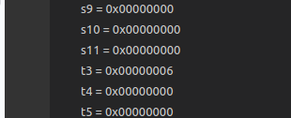

* + 1. We can continue, and the second iteration will execute.